# SPRINT DELIVERY PLAN

Team ID:PNT2022TMID30346

Project Name: AI-Based Localization and Classification of Skin Disease with Erythema

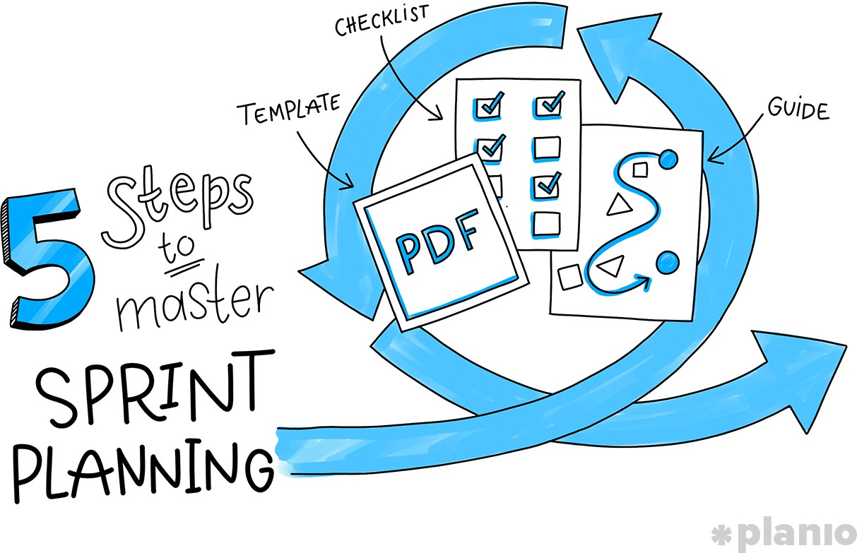

Sprint planning comes down to a few key steps, from making sure your product backlog is properly groomed to framing the sprint, and running an effective sprint planning meeting. In this guide, we’ll run you through everything you need to know.

Step 1: Review your product roadmap

Step 2: Groom your product backlog and update user stories

Step 3: Propose a sprint goal and backlog *before* the sprint planning meeting

Step 4: Use data and experience to supercharge your Sprint planning meeting

Step 5: Walk through each user story and describe what tasks need to be done

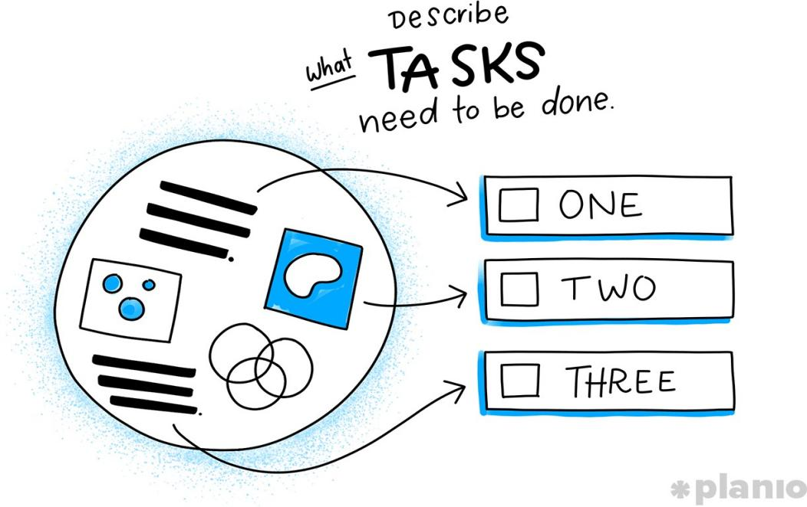

**Example / Application of Sprint Planning**

A company in charge of developing a set of HR products decided to make the products accessible through a single platform. The whole process involved one-hour software registration, recruitment, invoicing and personal planning.

The primary aim of the new product was to reduce the inconvenience caused by having several products with different dashboards, logins and purchasing procedures. The scrum team dedicated all their efforts towards completing the new product, and the whole process took a year.

They had two weeks’ sprint planning meetings. The team was cross-functional as they had skills in analysis, testing, visual designs development. Done definition for

the team had all the things necessary for release and production at the end of the sprint. Some of their rules were:

* All the web pages should not have dead links button that was inactive
* Webpages should be free from temporary images and texts
* Webpages should be in line with the latest version of Chrome, Firefox and safari
* A member of the team must preview the code for the item, and another verifies its functionality

The team then came up with a rough strategy for the first sprint, and it was as follows:

* They build a simple webshop where they placed their product catalogue for the customers to buy single products.
* The next step was to create a dashboard that allowed widgets from different products to be integrated into a single overview.
* The team concentrated on increasing the webshop that supports complex purchases with multiple users and licenses
* The last focus was producing a branded version of the available product to numerous customers

The above strategies helped the team form a goal for the first sprint, and they constantly revised the product backlog until they achieved what they wanted. After conducting a series of sprint planning review, the team finally achieved the following:

* The product catalogue was easy to manage for their sales department
* Customers were able to login to different products with a single sign-on
* Established a dashboard with a primary widget for the two common platforms
* They were able to guide the customers through the set-up and configuration after the purchase of product A and B
* Their venue was able to translate user messages and facing sites into the user preferred language